**ICACHE ERROR DOCUMENTATION**

**Introduction:**

The purpose of this document is to identify, categorize, and analyze errors observed in the icache implementation of the uetrv_pcore. It highlights the potential causes, impacts, and recommended fixes for these errors to ensure reliable system behavior.

**Overview of icache in uetrv_pcore:**

The icache module in uetrv_pcore is responsible for managing data memory accesses by reducing latency and improving performance. It handles features such as:

* Cache hits and misses.
* 4-way Associative
* Eviction and replacement policies.
* Handling memory requests and responses.

Errors in the icache can impact the overall performance, correctness, and efficiency of the processor core.

**Error no. 1:**

Icache in uetrv_pcore is 4-way associative, which means that it contains 4 sets of cache lines, tag, valid and dirty bits. However, just like dcache, the icache valid bits were initialized as don’t cares. Setting the valid bits as “don’t cares” affects the icache hit which indirectly affects the icache miss.



Icache contains 4 sets, due to which icache_rd_tag_way(n) where n= 0,1,2,3, n is number of sets and its most significant bit (bit number 31) of icache_rd_tag_way(n) is valid bit.

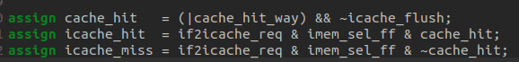

The above code shows cache hit directly affecting icache_hit and indirectly affecting the icache_miss.

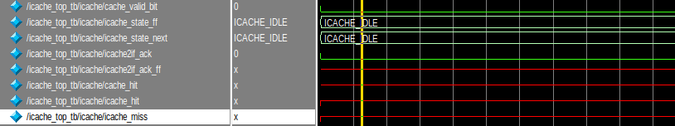

The above simulation shows icache_hit as don’t care.

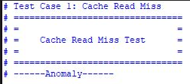

When testing is done, it shows anomaly which is an error and we need to fix this.

**Solution:**

We modified the code by adding a mux for cache validity.

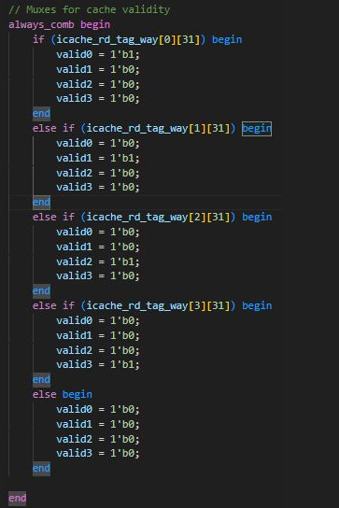

The always_comb block evaluates conditions based on the MSB (bit 31) of icache_rd_tag_way[x] for each way (0 to 3). If the MSB of a particular cache way is asserted (likely indicating the validity of that cache line), the corresponding valid[x] signal is set to 1'b1, while all other valid signals are set to 1'b0. This ensures that only one valid signal is active at any time, representing the valid cache way. If none of valid bit of set is 1 and all valid signals are set to default (1'b0), then cache_hit will not be don’t care which makes icache_hit and icache_miss zero.

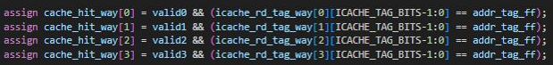

The above code contains the temporary signals (valid0, valid1, valid2 and valid3) coming from the muxes. These signals are used in assign statements of cache hits.

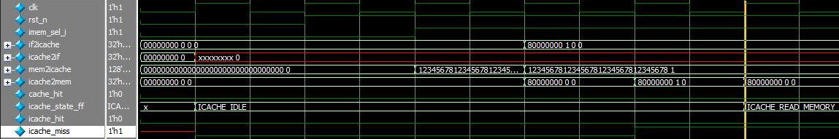

The corrected simulation doesn’t show “don’t cares” as before.

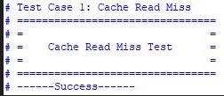

When testing is done, cache read miss shows success.

**Error no. 2:**

In icache, we have a variable named “icache_rd_tag_way” and its most significant bit is the valid bit. So, the error that we noticed was related to flushing.



In flushing, the valid bit is supposed to get 0 (at address 00000000) after flushing but in the above picture it can be seen that the valid bit is still 1 after flushing which needs to be corrected. Similarly, when testing is done, the result is shown as:

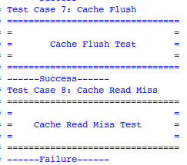

The testing indicates that the cache flush test is successful, but this conclusion is based solely on the appearance of the "flush done" signal. Whenever the flush done signal appears, the test is considered successful. However, for proper validation, we need to run the cache read miss test. This test is performed on the address where data was previously written before flushing. After flushing, the data should be removed from that address. However, since the test shows a failure, it indicates a cache hit, suggesting that the flushing was not performed correctly.

The code for flushing is shown as:

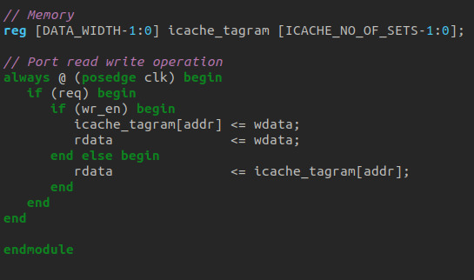

This code should be modified in order to solve this error.

**Solution:**

We modified the code by adding an “if” statement regarding flushing and wr_en signal which is shown below:

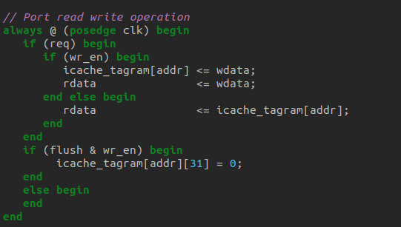

So, now testing will be done to check whether the flushing is showing the valid bit as 0 or 1.



At address 00000000, it can be seen that the most significant bit which is the valid bit is now 0 indicating that the flushing is working properly.

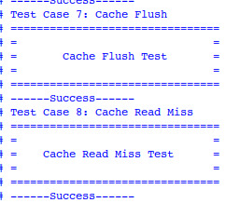

This shows that the cache read miss test is also a success, indicating that the data is removed from the address at which it was written at some point. After this, we will be getting a cache miss.

**Error no. 3:**

Suppose, we have an address and it gives us index 0, then we will write the tag and data at that index. But if we get another address of index 0, then we will overwrite the already written tag and data. For this purpose, 4-way associative cache is used in which we have 4 sets at one index. In this way, overwriting isn’t done and new data and tag is stored at different sets. In uetrv_pcore, 4-way associative wasn’t working properly. The code is shown below:

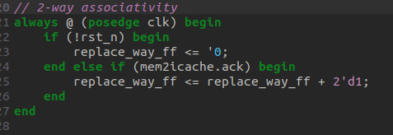

**Testbench for test cases:**

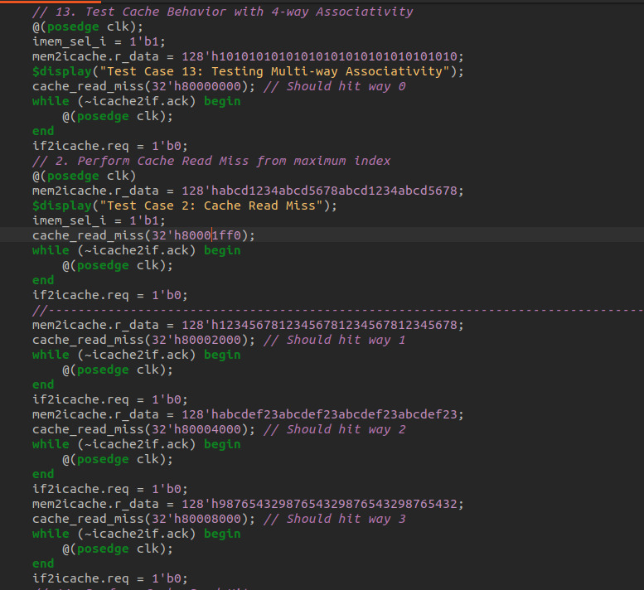

The above Testbench code is used for testing the associativity. In the above code, first of all, data and tag is written at set 0 of index 0, then it is written at some highest index and afterwards it is written at set 1, 2 and 3 of index 0. Now, none of the data and tag should be replaced, but when the testing is done, it shows different results.

**Tag in set 0, 1, 2 and 3:**

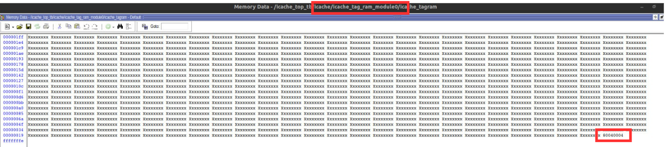

Here, it can be seen that the tag in set 0 has the address 80040004 which corresponds the address 0x80008000 defined in test bench. This kind of error is noticed for set 0, 1, 2 and 3, which needs to be resolved.

**Data in set 0, 1, 2 and 3:**

Similarly, this kind of error was also shown for data in set 0, 1, 2 and 3.

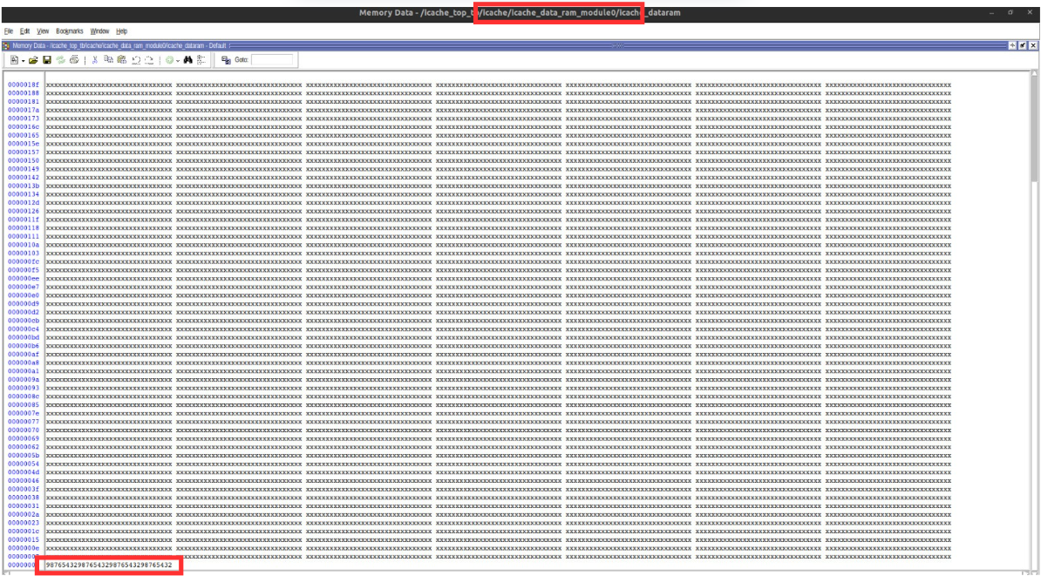

In the above picture, data in set 0 is different from the one defined in the test cases indicating that associativity behaviour isn’t done properly.

**Solution:**

The code was modified which is shown below:

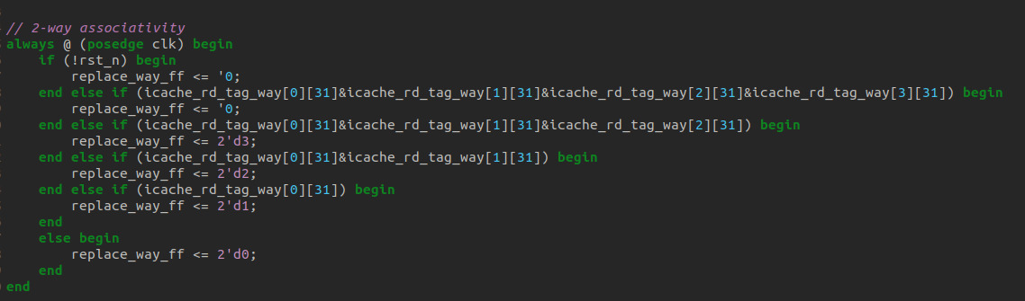

If the reset signal is active, replace_way_ff is set to 0 to initialize the system. The next conditions check if the **MSB (bit 31)** of all four cache ways is set, meaning all ways are valid, the replacement is assigned to way 0. If only three ways are valid, way 3 is chosen for replacement. Similarly, if two specific ways are valid, the replacement is assigned to an available way. If only one way is valid, another way is selected for replacement. If none of these conditions are met, it defaults to replacing way 0.

**Tag in set 0, 1, 2 and 3:**

**Icache_tag_ram_module0:**

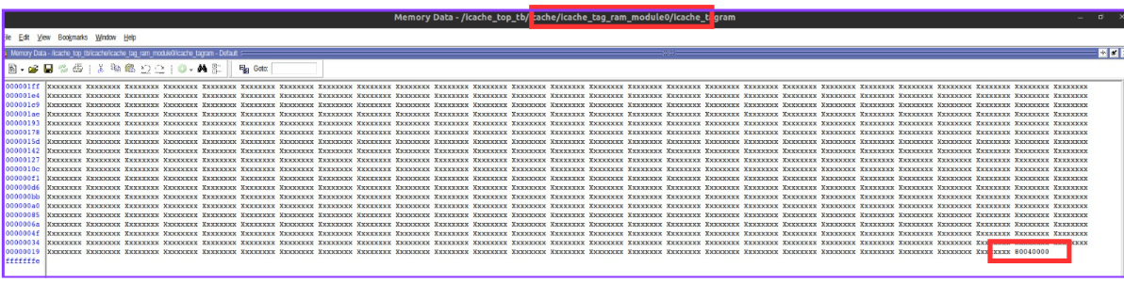

**Icache_tag_ram_module1:**

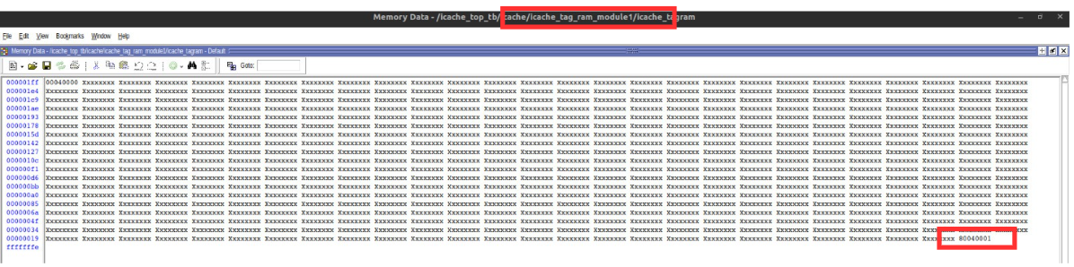

**Icache_tag_ram_module2:**

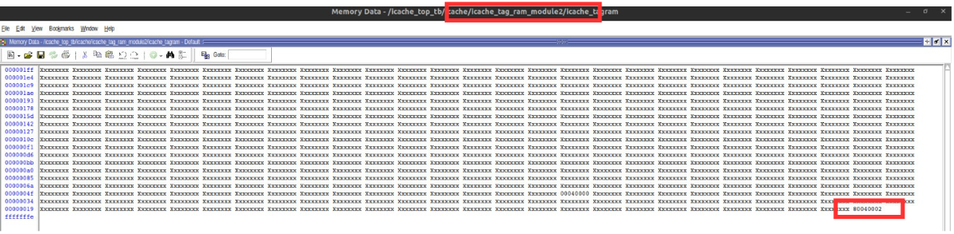

**Icache_tag_ram_module3:**

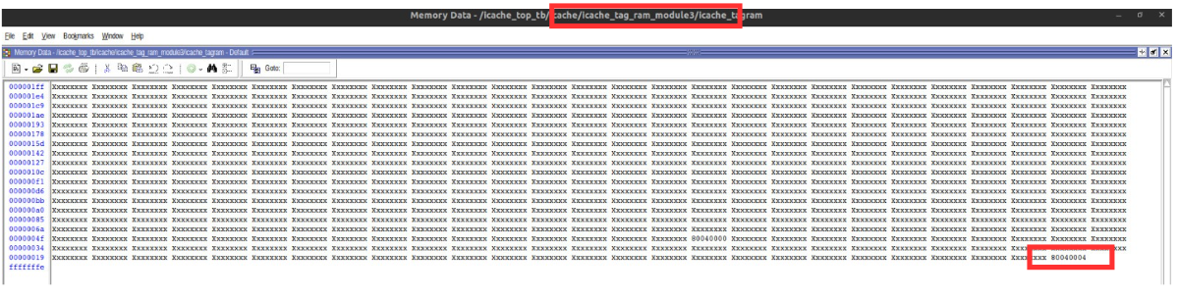

All of the above tags are in the right sets and in accordance with the defined test cases.

**Data in set 0, 1, 2 and 3:**

**Icache_data_ram_module0:**

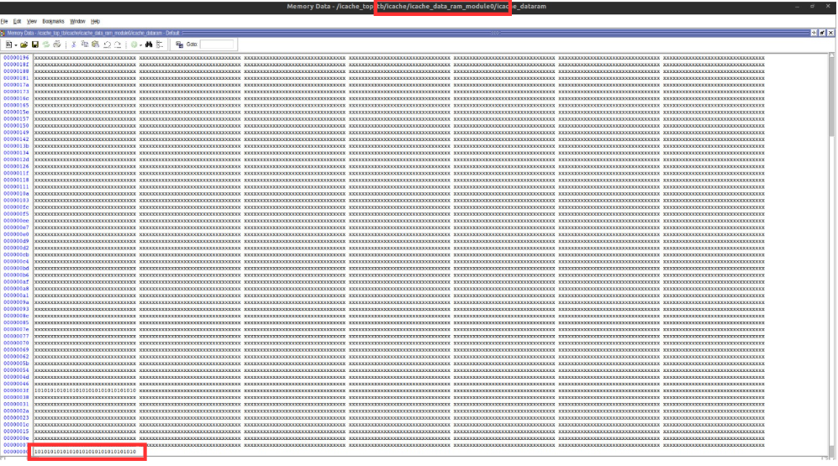

**Icache_data_ram_module1:**

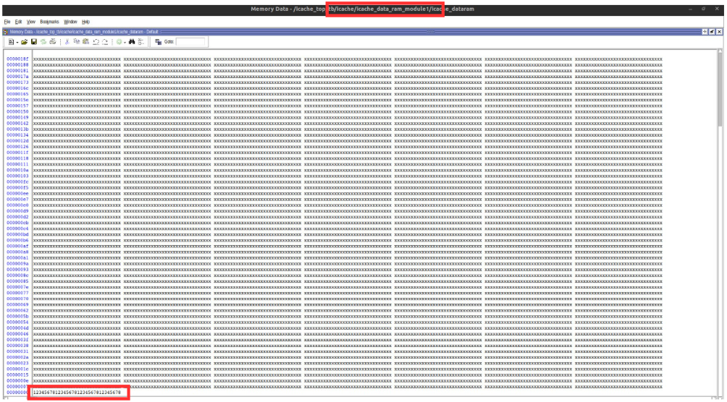

**Icache_data_ram_module2:**

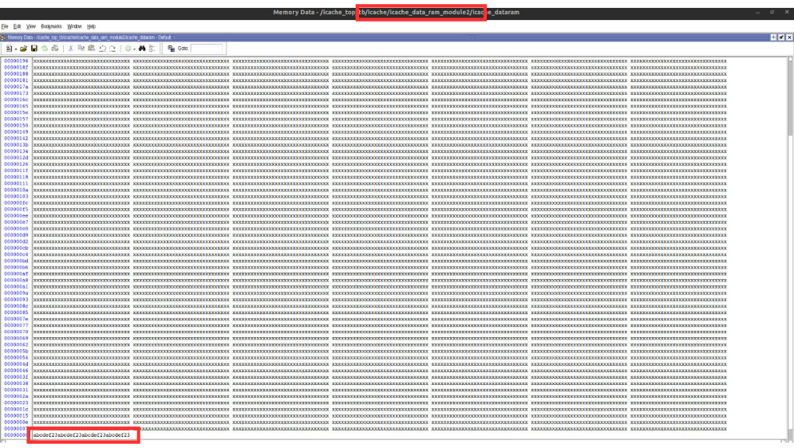

**Icache_data_ram_module3:**

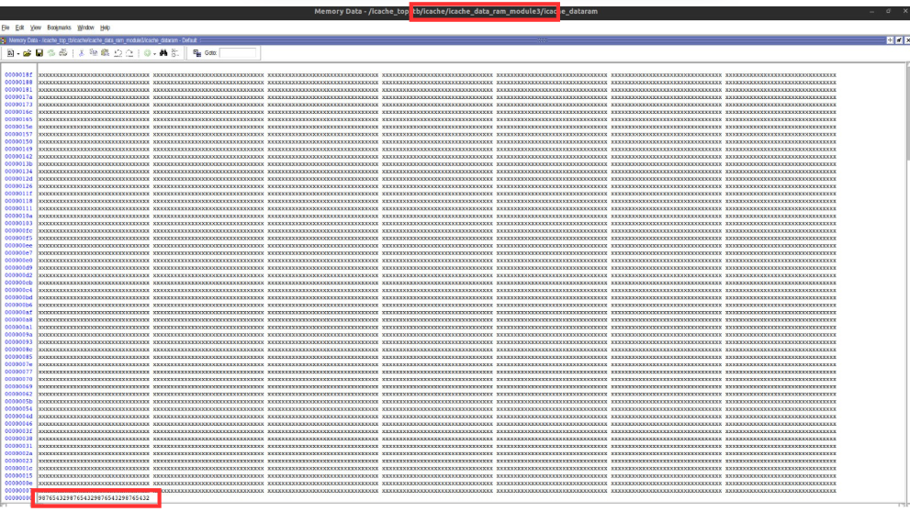

All of the above data are in the right sets and in accordance with the defined test cases.